

Faculty of Science and Technology

BSc (Hons) Game Design

May 2024

REBOOT:

*Exploring the Impact of Higher Skill Ceilings on Player Enjoyment and Retention Through a Fast-Paced Top-Down Shooter Roguelike Game*

by

*Alec Thurler Crauford*

**DISSERTATION DECLARATION**

This Dissertation/Project Report is submitted in partial fulfilment of the requirements for an honours degree at Bournemouth University. I declare that this Dissertation/ Project Report is my own work and that it does not contravene any academic offence as specified in the University’s regulations.

**Retention**

I agree that, should the University wish to retain it for reference purposes, a copy of my Dissertation/Project Report may be held by Bournemouth University normally for a period of 3 academic years. I understand that my Dissertation/Project Report may be destroyed once the retention period has expired. I am also aware that the University does not guarantee to retain this Dissertation/Project Report for any length of time (if at all) and that I have been advised to retain a copy for my future reference.

**Confidentiality**

I confirm that this Dissertation/Project Report does not contain information of a commercial or confidential nature or include personal information other than that which would normally be in the public domain unless the relevant permissions have been obtained. In particular, any information which identifies a particular individual’s religious or political beliefs, information relating to their health, ethnicity, criminal history or personal life has been anonymised unless permission for its publication has been granted from the person to whom it relates.

**Copyright**

**The copyright for this dissertation remains with me.**

**Requests for Information**

I agree that this Dissertation/Project Report may be made available as the result of a request for information under the Freedom of Information Act.

Signed: A. Crauford

Name: Alec Crauford

Date: 12/05/2002

Programme: BSc

**Permission for use of produced work**

We ask you to sign this form because Bournemouth University Higher Education Corporation (**BU**) may wish to use your Individual Project material (in its original or an amended form) for marketing purposes in one or more of the following ways:

* prospectuses and other BU promotional materials, including promotional videos
* as part of an advert or advertisement feature (which includes possible use on outdoor media such as buses and billboards)
* on the BU websites or intranet
* at open days
* in social media

If we used it, you would receive exposure for your work. You do not have to agree, and not doing so will have no effect on marking your Individual Project material. For ease this is simply called Material below.

If you are kind enough to agree to BU having rights of use and editing, this will not affect your ownership rights in the Material or your right to use it for your own professional or personal reasons. Unless it is impractical to do so – for example a montage on social media where space limits may apply, BU will ensure that it credits you for BU’s use of the Material.

**By signing this form:**

* I grant a non-exclusive, world-wide, royalty-free licence to BU to use and sub-licence the Material, for marketing purposes; and I waive any non-property rights (including moral rights) now or in the future existing. This licence includes the right to edit and create derivative works from the Material, for example, a multi-student showreel.
* I agree this licence shall subsist permanently unless I seek to end it in line with the procedure below; but that where BU has already used, or is committed to using, the Material for a particular marketing campaign - for example, in a prospectus already printed, any ending of the licence shall relate only to new uses of the Material.
* **I understand BU will not ask me for any further approval or permission for specific uses of the Material for marketing purposes; but that I can withdraw my permission at any time, with the consequences for continued use set out above.**

If you wish to withdraw your permission for use of your information, please contact the Programme Support Officer by e-mail scitechcreativepso@bournemouth.ac.uk.

Otherwise, we will keep your Material and associated personal information for as long as we have any plan to, or actively, use the Material for marketing purposes.

The legal basis for BU processing your personal information is consent, that is by signing this form you are giving permission to use your personal information provided in, and in relation to, the Material for the purposes set out above.

In processing your personal data, BU complies with the Data Protection Act 2018 and General Data Protection Regulation (Regulation (EU) 2016/679). You can find further information about BU’s data protection and privacy approach here: https://www.bournemouth.ac.uk/about/governance/access-information/data-protection-privacy.

Further information about your rights under the data protection legislation can be found from our Data Protection Officer on [dpo@bournemouth.ac.uk](mailto:dpo@bournemouth.ac.uk).

I give permission for BU to use my Material on the basis set out above:

Signed: A. Crauford

Name: Alec Crauford

Date: 12/05/2002

# Acknowledgements

There were several people involved in making this project happen and without them I believe the end product wouldn’t be something I am as proud of as this project.

I would like to extend a special thanks to Andrew Watson, Senior Lecturer in Electronics at Bournemouth University who was my primary supervisor. Without his support and guidance, I don’t believe anything would’ve been finished on time. I would also like to express my gratitude to Glyn Hadley, Senior Lecturer in Creative Technology at Bournemouth University and Vedad Hulusic, Associate Professor & Deputy Head of Department In Creative Technology who were my secondary supervisor and unit lead respectively. I cannot understate how much the three of them and the rest of the teaching staff in the Games Design course have taught me through the last 3 years.

I would also like to thank my friends and acquaintances that took place in my study, even if a few of you weren’t available to the questionnaire, I still appreciate that they took time out of their days to test my product and give me feedback. I would like to thank Oliver Langford, Pedro Palermo and Bernardo Hita specifically as they supported me throughout the whole process, with Bernardo being in charge of the sound effects and music present within the game. Lastly, I would like to thank my family for being there for me emotionally, even though we live in different continents they were there for me every single time I needed them.

# Abstract

While most would imagine that hard and challenging games are played by only a few, many titles with both high skill floors and high skill ceilings have become extremely popular within the recent years. Entire genres have been created that are purely about failing, and contrary to popular belief they’ve sold millions of copies. This study aims to understand the effect these games with higher skill ceilings have on player enjoyment by developing a fast-paced top-down shooter roguelike game. By taking the quantitative and qualitative data gathered from participants about the game and comparing it to data gathered by older research a more concise answer is achieved. while trying to figure out the broad effects that high skill ceilings have within the world of video games, the study also gathers convincing data that is supported by previous research regarding mastery orientation and how most of these games appeal to them more than any other group of players. To understand the effects of high skill ceilings the study first looks at how players reach that level in the first place, by failing and not giving up.

Table of Contents

Faculty of Science and Technology - 10 -

*Exploring the Impact of Higher Skill Ceilings on Player Enjoyment and Retention Through a Fast-Paced Top-Down Shooter Roguelike Game* - 10 -

Acknowledgements - 14 -

Abstract - 15 -

1.Introduction: - 17 -

1.1 Context and Motivations: - 17 -

1.2 Aims and Objectives: - 17 -

2.Background: - 18 -

2.1 Exploring difficulty, challenges, and failure: - 18 -

2.2 Academic Studies: - 18 -

2.3 GAMES: - 19 -

3.Design and Implementation: - 20 -

3.1 Planning and Development: - 20 -

3.1.1 Original Concept: - 20 -

3.1.2 Development Strategy: - 21 -

3.2 Development Details: - 21 -

3.2.1 Understanding Roguelike Mechanics: - 21 -

3.2.2 Implementing Roguelike Mechanics: - 22 -

3.2.3 Basic Top-Down Mechanics: - 23 -

3.2.4 Skills and “Ultimates”: - 23 -

3.2.5 Enemies and Bosses: - 25 -

3.2.6 Upgrades: - 26 -

3.2.7 Shop and Currency: - 27 -

3.2.8 Statistics needed for the study: - 27 -

3.3 Graphics and appearance: - 28 -

3.4 Sound Design: - 29 -

4.Method, Evaluation and Reflection: - 29 -

4.1 Method: - 29 -

4.2 Evaluation and Reflection: - 29 -

5.Conclusion and Future Work: - 31 -

5.1 Conclusion: - 31 -

5.2 Future Work: - 31 -

References - 32 -

Academic References - 32 -

Bibliography - 32 -

Ludography and Digital References - 32 -

# 1.Introduction:

For as long as games have existed the discussion of how accessible and challenging they should be has been a hot topic. Both aspects can occasionally seem to go against each other but in reality, a balance of both is important if a developer wishes to avoid ostracizing part of their potential player base. Although it may seem counter intuitive to some there are players that will seek a challenge as discussed by Craig Anderson and the rest of the team (C. Anderson et al 2019) “Mastery oriented individuals are characterized by positive reactions to failure, such as renewed effort, heightened affect, and positive, affirming language.” With the evolution of video games, players have also gotten better with time, leading such individuals to look for increasingly harder games or games with a higher skill ceiling. This study aims to better understand this phenomenon through the lens of a top-down shooter roguelike game.

## 1.1 Context and Motivations:

As previously mentioned, a phenomenon more commonly seen in recent years is the rise of increasingly difficult and punishing games. Some of these games have given rise to entire franchises with the most popular example of “Dark Souls” having given birth to the “Souls like” genre. The Souls games, which are developed by FromSoftware, have for the most part received critical acclaim to the point where stating a game looks like a FromSoftware game is seen as praise. It is important however to recognize that there are multiple other genres that have gained recognition for being hard, one of these genres has been pushed to the mainstream due to the rise of streaming platforms and is known as “rage games”. Streaming platforms helped the “rage games” genre to flourish as thousands of viewers gravitated to the idea of seeing their favorite content creator suffering at the game rather than playing it themselves, turning the rage part of the genre into a spectacle with much wider appeal. Some noteworthy games of this genre are “Getting Over It with Bennett Foddy” and “Jump King” which are both platformers where the player could lose hours of progress for every mistake. Most would assume that both genres would have remained mostly unknown as games have mostly been used as medium to destress and relax, this is clearly not the case as all the games mentioned so far have sold more than a hundred thousand copies. This however raises a question this study would like to answer, “How do higher skill ceilings impact player satisfaction and retention?”.

## 1.2 Aims and Objectives:

To answer such a question the creation of a game that has both a higher skill ceiling and a way to measure such metrics is necessary. Therefore, the first aim is to identify what is needed for a higher skill ceiling and what have games in the past done to measure similar metrics in a way that is rewarding and interesting for the player. Once the game is complete, distributing it and gathering the required data will in turn make it easier for game developers to properly understand what challenges players crave and which ones they avoid.

# 2.Background:

## 2.1 Exploring difficulty, challenges, and failure:

Once challenge and failure are looked at as a motivator for players rather than a byproduct of others winning, the concept of what makes a game fun and fulfilling becomes easier to understand. A player must fail to grow; therefore, a high skill ceiling game must include many challenges that will cause the player to improve without demotivating them. It is important not only to understand how to make a player fail, but also how to make a player fail in a fair and satisfying way. When dealing with punishing game mechanics such as “permadeath” a player’s success should be linked directly to their performance. Many games have proved before that failure doesn’t have to result in player frustration and loss of interest. By looking at previous studies and popular games within the genre it is possible to better understand what will make failures and setbacks less of an issue for as many players as possible, reframing such losses for the player is crucial to make a high skill ceiling game that will keep players engaged and satisfied.

## 2.2 Academic Studies:

**Title:** Building persistence through failure: the role of challenge in video games

**Authors:** C.G. Anderson, K. Campbell, C. Steinkuehler

This paper explores the importance of game developers creating challenging environments that will cause the player to fail as a way to allow them ways to develop the skills and knowledge that will be necessary for beating the game and how different people react to failure in different ways, specially how people that are “mastery oriented” will use failure as information to better solve problems moving forward rather than a representation of their current skill level or performance. C. Anderson, K. Campbell & C. Steinkuehler (2019, p.1) states that “players do not desire to simply win, but to experience a “well-played game”. This requires players to search for the optimal level of challenge, often inviting failure with it”.

**Title:** Player Performance, Satisfaction, and Video Game Enjoyment

**Authors:** Klimmt C., Blake C., Hefner D., Vorderer P. & Roth C.

Discusses how to a lot of players fun is directly linked to their performance rather than the perceived difficulty or challenge of a game. The study shows that most players with less experience in a genre prefer and experience that is easier, with many success experiences (in this case kills as it is a First Person Shooter) and few failures (Deaths). This result begins to change drastically as players improve, illustrated by the mean score for enjoyment steadily increasing for the more difficult experience while easier experiences remain mostly the same (Klimmt et al 2009, p.9) “Our attempt to integrate these findings with previous research is focused on the issue of playing time. We suggest that the relationship between game difficulty, success rate, internal attribution of success, satisfaction with own performance, and overall game enjoyment changes over the time of using a given game.”

**Title:** Fail, fail again, fail better: How players who enjoy challenging games persist after failure in “Celeste”

**Authors:** Hefkaluk N, Linehan C and Trace A.

Focuses on how giving meaning and purpose to failure will allow the player to be better prepared for difficult situations and experiences. Study emphasizes how having clear goals gives rise to in-loop failures, which have a much more benign effect on the player, rather than out-of-loop failures, which can diminish motivation and self-esteem of players. The study concludes that goals that improve the players own mastery or skill are much better at keeping player motivated (Hefkaluk et al 2024, p.2) “Goals which endorse competence gains and seeking out failure to learn (mastery approach goals) motivate individuals more than those endorsing public displays of competence (performance approach goals).”

**Title:** Try Again?: A Macro-Level Taxonomy of the Challenge and Failure Process in Games

**Authors:** Cuerdo M, Mahajan A, Mao J and Melcer E.

This study delves deeper into what it describes as the three main components of failure within video games. A failure starts at player challenges can be subdivided into 3 parts: game modes, obstacles, and embodied actions. Once the challenges are introduced a failure can be divided into two different types, Mini Failure Loops, and Critical Failures they are described as (Cuerdo M. et al 2023, p.4) “Entering this inner loop means that the player faces a mini/partial setback in gameplay that temporarily hinders the game progression” and “The other potential fork in gameplay from Player Challenges is to go directly to the Critical Failure State. This refers to the end of a game run that is reached when a failure condition is reached.”

**Title:** Hits, Quits, and Retries - Player Response to Failure in a Challenging Video Game

**Authors:** C. G. Anderson

The paper makes use of a notoriously difficult platformer called Cuphead to test what people consider a failure and how that affects them, in the end it becomes clear that what is considered a failure or mistake will vary depending on the mastery of the player in question, players that are further ahead in terms of mastery will see things like “taking damage” and “deaths” as small setbacks (C. G. Anderson 2020 p.2) ”Players also often spoke positively about failure in their play, regarding it as a benefit overall rather than a detriment.”

## 2.3 GAMES:

1. **Roguelikes:**

As the game is going to be a roguelike a lot of research was done in regard to the genre. Hades provides a great example of everything that can be done within the genre. Having won multiple game of the year awards it sets the bar high on what can be achieved with its gameplay mechanics, art direction and non-linear storyline. Binding of Isaac is another insanely popular game within the genre of roguelikes, having sold over 11 million copies. It provides a great starting point on what to do and what to avoid as it is also a top-down shooter. Out of all games investigated for this study Binding of Isaac is the closest to the game described as the aim and objective. Unfortunately, both games possess incredibly expansive “upgrade” and “build” systems which would be unattainable within the time frame of the project. Due to this many indie roguelike games were looked into for inspiration, Gunfire Reborn possesses a simple yet effective build system that is both easy to understand and easily expandable if needed.

1. **Platformers:**

Although the rage platformers previously mentioned in Jump King and Getting Over It with Bennett Foddy don’t have much in common in terms of what REBOOT is supposed to be, they do provide a few valuable lessons on both what to do and what not to do. These games have been designed with failure as its main focus point, which is something the player will need to go through in order to be able to raise their level of mastery or skill. When looked through the lenses of the previously mentioned studies it becomes clear that both games were developed specifically for “mastery oriented” individuals, there are no possible “critical failures” but the “mini failure loops” encountered are quite harsh, sometimes bringing the player to the very start of the level. This design will in turn ostracize every player that does not fit within the criteria, as the only motivation for playing the game is improving one’s gameplay and beating the game. There are no side quests or expansive stories that will keep players engaged. The one way it achieves keeping “mastery oriented” individuals interested is by giving the player complete control over the results, the gameplay is crisp with no randomness and the level itself is always the same, by keeping the game this way all it takes to beat the game in its entirety is practice and knowledge.

# 3.Design and Implementation:

## 3.1 Planning and Development:

### 3.1.1 Original Concept:

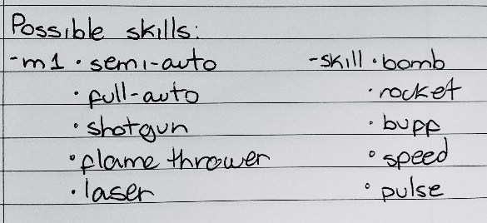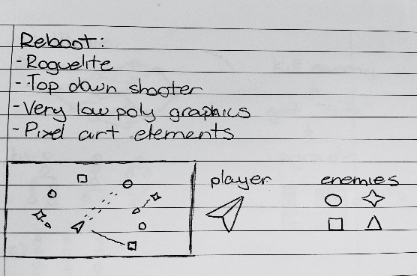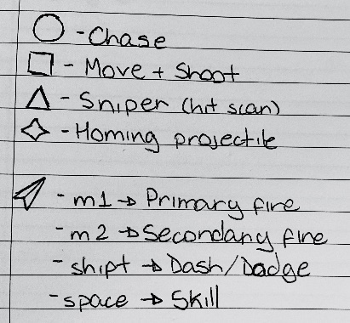 Before any development was made an original concept covering most aspects of the game was created.

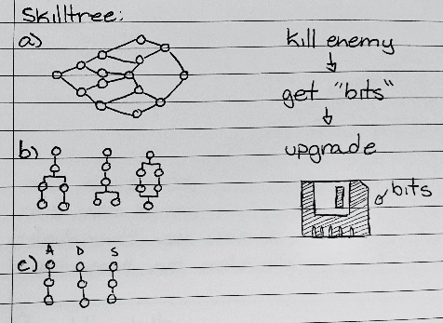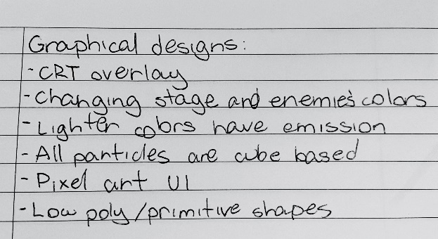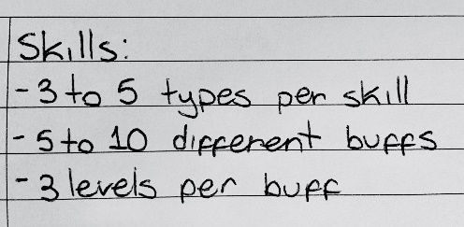Figure 1. Scan of original game concept sketches, first image contains general ideas and an illustration of how the game will possibly look, second image contains general enemy behavior ideas and player controls, and the third image contains possible weapons and skills.

Figure 2. Scan of original game concept sketches, first image contains more details about the planned upgrade and build system. Image two contains descriptions of the planned graphical interface, post processing and style. Lastly, the third image contains different concepts for skill trees that would be unlocked through the use of “bits”.

As seen on figure 1 and figure 2 the concept covers the gameplay, build and upgrade system (including possible skills and weapons to be included), the general desired graphics and lastly a skill tree system using the in-game currency. The concept is quite broad and lacks more visual representations, but if achieved it will be sufficient for the study. It was decided that the graphics must be simple, this will help avoid visual clutter and remove the possibility of players being overwhelmed as the gameplay will be fast paced. An existing style that achieves this is the style of old arcade games. Old arcade games such as Donkey Kong and Pacman have notoriously high skill ceilings and have made way for a style that is incredibly simple and striking. To achieve increasingly simple yet easy to understand graphics, colour and shape theory will be used. Enemies will be constructed by 3D shapes and coloured red while the player will look flat and the colour blue, separating the two very clearly. Most of the visual information will be contained in the UI which will be made through pixel art/font and the post processing will bring both together by using a CRT filter, bloom and other effects that will serve to make the game look like an old arcade game. The player will have 3 actions that he is capable of doing besides moving or shooting. Mouse two will use a skill that is on a time cooldown after use, the space bar will be used for ultimate skills which can only be used after gathering a resource known as “fury” (the player gets 5 fury for each enemy killed and requires 100 to use the ultimate skill once) and lastly shift will be used for the sprint or dash (will use a “stamina” system). There will be around 9 to 15 total “build parts” (3 to 5 different weapons, skills, and ultimates), the number might change due to time constraints, and preferably at least 5 possible upgrades for each of those build parts. Lastly a “skill tree” system for the player to upgrade stats in between runs would provide some extra incentives to prolong play time.

### 3.1.2 Development Strategy:

Due to the present time constraints development took place in stages that were designed to prioritize core components and mechanics. By prioritizing different aspects of the game, it was possible to have “test versions” of the game a long time before the game was properly finished. For example, the first test version only had a few skills and ultimates and only the first enemy archetype was present. This version was rigorously tested to make sure the way the level changes was functional, and that both player and enemy damage were working as intended. After each core feature was added another batch of tests would take place, ensuring every part functioned before the whole game was completed. This made debugging each feature easy as at each point there was always only a limited number of scripts that could be causing the issue.

## 3.2 Development Details:

### 3.2.1 Understanding Roguelike Mechanics:

To better develop the roguelike aspects to the game it is important to breakdown the core mechanics of the genre into its simplest form, making it easier to understand what it is attracts player to this genre. After observing multiple games within the genre there were three mechanics that stood out as being Indispensable. The first being the concept of “permadeaths”. In most game genres dying is usually followed by a respawn, that is not the case in roguelikes. Once a player dies within a roguelike they must restart the game, there is usually no way to keep going from where they experienced failure. With this in mind it is easy to understand why the roguelike community refers to in game lives as “runs”, once the player dies their current playthrough is over and they must now attempt to run through the game again. By itself the mechanic of permadeath would be considered a critical failure by every possible player base, what makes this mechanic less punishing and keeps the game fresh is the introduction of two other core mechanics. Randomness or RNG (random number generation) is the second core mechanic of most roguelikes. As this is much more broad “mechanic” it can present itself in many ways within the game. Usually enemies, maps and rewards have some sort of RNG associated with them to make the game play slightly different every time the player starts playing. Another way a lot of roguelike games keep players playing for longer is by locking certain content behind in game achievements. For example, within Gunfire Reborn there are many weapons you cannot get during your first runs as they are only added to the RNG “pool” (pool refers to all the possible items that can be randomly generated) after beating specific bosses or completing specific challenges, that way the more you play the game the more variety you will encounter within the rewards you receive. The last core mechanic of roguelikes is directly tied to the RNG factor and is usually referred by players as “builds” (a build usually refers to all the different upgrades and gear a player can acquire during their runs). By having the players’ power and options be linked to RNG to some extent, it is possible to add a lot of variety to the “feel” of each run. Sometimes the player will get bad gear or good gear that doesn’t synergise with each other leading them to feel like they need to use everything they have to the best of their abilities, incentivising good gameplay. Other times they will get incredible builds where all their gear comes together in a way that makes them feel exponentially more powerful, the rarer this is the more rewarding it is when it happens. With all these mechanics in mind it is clear that a successful roguelike requires some sort of randomness to avoid repetitive gameplay but not too much as that would remove player agency.

### 3.2.2 Implementing Roguelike Mechanics:

When it comes to REBOOT there are two very distinct used of RNG, the first is the RNG that affects the game world. The clearest example of this is the changing layout of the game. The game takes place over many different levels, all of which randomly get assigned a wall and hazard layout. As seen on Figure 3 each of these layout pools have 10 options, leading to a total of 100 possible map combinations, meaning that the odds of the player getting the same map combination twice in one run is relatively low. The only exception to this rule is for boss levels. Similar to the diagram in Figure 4 there is a check that happens at boss levels and instead of spawning a random layout and hazard it simply spawns a specific hazard set that was chosen for boss levels. It does not spawn a wall layout in this case.

Figure 3. Illustrates how a new layout and hazard is chosen every level.

The second type of RNG is directly associated with the player, in this case there are 2 distinct applications of RNG: rewards and build components. Rewards refer to what the player receives at the end of each level, these can be a random upgrade, healing, or “bits” (in game currency). There is a fourth reward, but it is not part of the RNG because, as seen on Figure 4, it is guaranteed after bosses.

Figure 4. Faux coding diagram explaining how the reward is picked, this operation happens once per door as each door can have a different reward.

Build component RNG can be split into 2 parts: new tools and upgrades for current tools. The reward guaranteed by bosses gives the player a new tool, depending on which boss this will vary between a weapon, a skill or an ultimate. Each of these has 5 different options, of which the player will only see 3 per run, meaning there is a total of 5^3(125) possible builds. Lastly all those aspects of the build can be upgraded throughout the run, as seen of figure 5 each gun has 5 possible upgrades, but ultimates and skills only have 3 each. Some of these upgrades completely change how the “tools” work, for example the normal SMG (submachine gun) is fully automatic with low damage but there is an upgrade that turns it into a semi-automatic burst weapon with increased damage compared to its base form. Lastly comes permadeath which doesn’t require any additions, simply returning the player to the menu upon deaths.

Figure 5. Diagram representing all the existing guns, skills, ultimates, and their respective upgrades.

### 3.2.3 Basic Top-Down Mechanics:

Top-down shooters have two core mechanics, moving on a 2D plane and shooting on a 2D plane. Both mechanics are very simple but similar to the platformers mentioned previously, it is important that they always work in the same way every single time. There will be no RNG involved with these mechanics as they are the main way the player interacts with the game world around them. The actions related to moving were bound to the standard keys of WASD, in the end it was decided to keep the movement vector unnormalized as this way moving diagonally gives a slight speed boost to the player. This speed boost doesn’t add any randomness to movement but adds another way players can express their skill and mastery, raising the skill ceiling by a small margin. Every time the player shoots it goes directly to where their mouse cursor was on the screen, the only exception is the shotgun as it fires multiple bullets at the same time in a spread manner. Weapon bloom and recoil were considered at one point, but they added multiple instances of “failure” that couldn’t be avoid through player skill, leading to their removal. Lastly, there are 5 different weapons the player can use that function differently from each other. The first is the pistol, it has a low fire rate and medium damage. The second is the rifle, it is fully automatic with medium damage and fire rate. The submachine gun is like the rifle, but it has a higher fire rate and lower damage. Lastly, there is the two more unique weapons, the shotgun, and the bazooka. Both have a very low fire rate as each shot has the potential of being very impactful.

### 3.2.4 Skills and “Ultimates”:

As mentioned previously the build system is incredibly important to the longevity and success of a roguelike, without enough options the build diversity will inevitably become repetitive and suffer from a lower skill ceiling, as the smaller the number of options available the less the player can learn and use the variety to their advantage. With this and the time constraints in mind 5 skills and 5 ultimates with 3 possible upgrades each is attainable and provides a satisfying amount of variety for players. Each of these skills and ultimates function vastly differently from each other, with some having incredible synergy with each other. This will eventually lead to a META (most effective tactic available) being found and developed, but as long as it is not oppressive enough to make the other options available unsustainable it should be fine for the requirements of the study. If one or a few options are much stronger than others, players will inevitably gravitate towards them, lowering build diversity even when there are many other options available. To avoid this issue, every available option should have its own benefits and drawbacks that will fit the play style of different players. For example, if the player chose the bazooka for their weapon they will struggle with close range enemies. This will in turn make the burst the best skill option for them, as it specializes in taking down close-range enemies. A newer player will not have this knowledge and therefore have a harder time then players that have achieved a higher level of mastery, but as Craig Anderson states (C. Anderson et al 2019, p.5) “Video games provide players with environments that are designed to push players to the limits of their ability. Failing is common practice in these spaces and holds promise for helping players to develop the strategies that help them deal with failure in better ways.”.

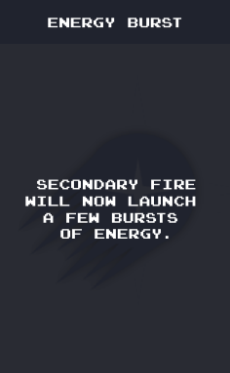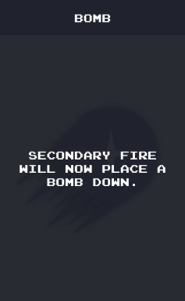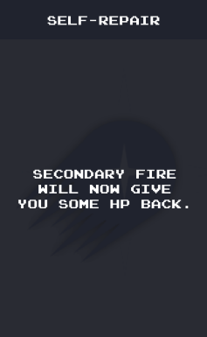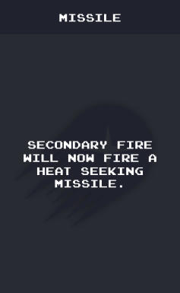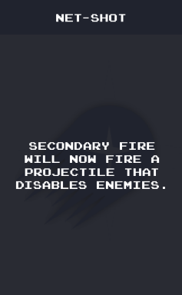 As seen in figure 6 the five available skills are a timed bomb, a missile that tracks enemies, a burst of energy around the player that does area damage, a bullet that disables enemies temporarily and a heal ability that give the player some health back.

Figure 6. The Skill cards the player has a chance of finding in game each will have a different effect and give the player access to a different skill.

Each of these skills fits a different playstyle and requires different circumstances to truly shine, this gives way to player skill expression in two very different ways. The first is regarding the mastery of each individual skill, as each skill plays very differently from each other just because a player has mastered one of them doesn’t mean they will have mastered the rest. The second type of skill expression comes from the fact that it is very unlikely for the player to receive their chosen skill every run, this will lead to runs where they will have to play will underperforming or low synergy builds, requiring smarter play for any success to be achieved.

### 3.2.5 Enemies and Bosses:

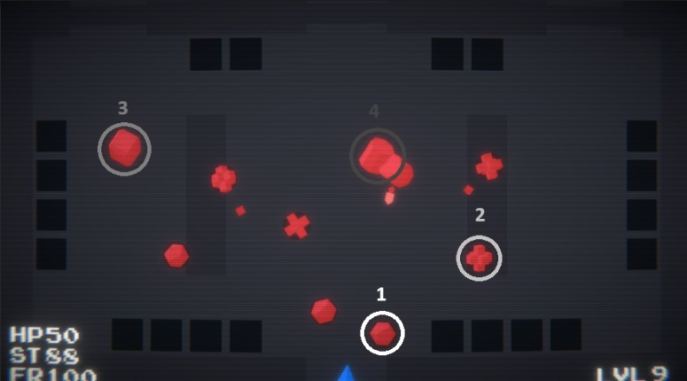 When it comes to a “Player vs AI” game enemy behaviour and balance are incredibly important as it is the main way the players mechanics will interact with the game world, fighting and destroying enemies is what players will spend the most time doing. Because of their prevalence in every gameplay session, most failures and challenges players encounter will be due to the enemies. To achieve a satisfying yet challenging fight four different basic enemy archetypes were created.

Figure 7. Screen capture of the game containing all enemy archetypes, they have been circled in different colours and have their respective number on top of them.

As seen on Figure 1 and Figure 7 the 4 enemy archetypes are distinct, and each have a different preferred range or method of doing damage. Enemy one will chase and collide with you doing melee damage. Enemy two will attempt to get around 2 meters from the player, at which point it will stop and fire bullets. Enemies three and four are completely ranged and will therefore maintain their distance from the player, moving backwards if the player gets too close to them. Enemy three will shoot homing missiles that explode after 4 seconds while enemy four will fire bursts of bullets in the player’s direction, the idea of a sniper enemy was scrapped as it was slowing down the pace of the game too much.

Figure 8. Screen capture containing the first boss, he is firing 4 missiles at the player character.

To add another layer of challenge an enemy “boss” was added every five levels. For the most part the boss has attacks that are upgraded versions of the attacks the default enemies use. For example, in Figure 8 you can see that the first boss is firing 4 rockets at the player, instead of just one like the normal enemies. There is a 3 bosses total as the game has 15 levels, they are all variations of the same boss but the bosses “move pool” (the moves it can use) increases every time it shows up, increasing the challenge of the fight every time.

Although it may seem like 4 distinct enemy objects and 3 distinct bosses will be needed to achieve their different behaviours, there is only one enemy object and one boss object. The enemy script contains a public variable that is denominated as the enemy ID, which the script will take and, as seen on Figure 9, use to change both the mesh and which behaviour tree it follows. The enemy ID is decided by the level manager, for the first 4 levels only enemies that are of ID 1 or 2 will be created as the player doesn’t have any tools besides the primary weapon.

Figure 9. Diagram containing simplified faux programming of enemy behaviour and how the enemy ID system works.

Bosses work in a very similar way, having their own ID system. The main difference between the two is that the boss only has one behaviour tree that can be simplified to: follow player, if (can use attack) -> attack; else -> attack cooldown -= time passed. The boss ID serves to decide which of the attacks contained within the script the boss can use. The first boss has two attacks, while the second boss has three and the third and final boss has six. The three attacks that are unique to the last boss are much more impactful than the ones from boss one and boss two, this makes it so the final boss is a lot more challenging, giving players a true test of skill even though they are the strongest they can possibly be due to having all abilities and multiple upgrades at this stage of the game.

### 3.2.6 Upgrades:

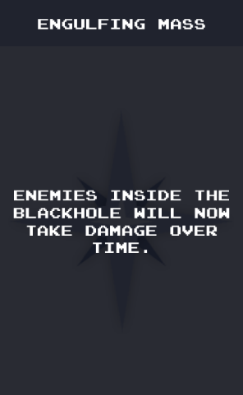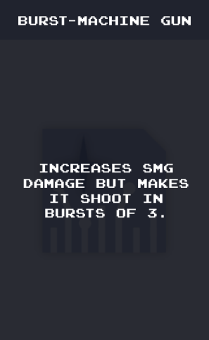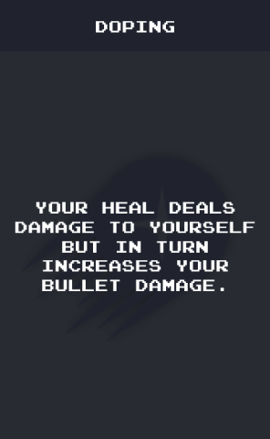 The original goal of having 5-10 upgrades for each weapon and ability was too much information for players to take in within the allotted play time for testing as it would’ve led to the creation of at most 150 unique assets that each had the power of affecting the player. In the end it was decided that each weapon would have 5 unique upgrades, with at least one of them completely changing how the weapon works (examples included on figure 10). Abilities and ultimates each received 3 unique upgrades, all together there is a total of 55 unique upgrades.

Figure 10. Some examples of upgrades that can be found within the game, the first card is for the heal skill while the second is for the black hole and the third is for the submachine gun.

### 3.2.7 Shop and Currency:

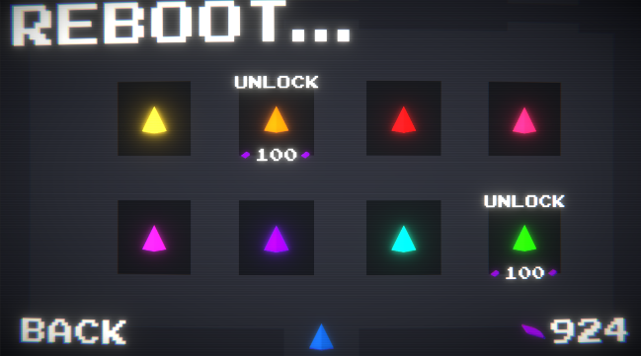 Originally the concept involved the idea of a skill tree that allowed the player to gain power in between runs through the use of bits. This would in turn give the player something to work for besides beating the game, by having a greater objective that is not bound by failure even players that are not mastery oriented would see dying as a setback to their main objective rather than a critical failure which as Craig Anderson states (2020, p.2-3) “Upon failing, their strategy use deteriorates, and ineffectual responses increase. Helpless-oriented individuals show an absence of progress after failure, report negative self-conditions, negative affect including boredom, aversion, anxiety, decreased performance, and use of ineffective or impossible strategies [9]. Failure completely stops helpless-oriented individuals in their tracks, whereas mastery-oriented individuals are invigorated by failure, renewing their efforts and resolve.”. An issue arose with this feature however, the skill tree was allowing the player to improve without the need for them to raise their own skill level. Due to this the skill tree had to be removed from the research version of the game, as it obfuscated results by making higher scores become a result of play time rather than mastery. To avoid the reintroduction of the issue mentioned above, a shop was created and put in place of the skill tree. As seen in Figure 11 the shop contains 8 colors players can use their bits to purchase, each costing 100 bits. With the total price of 800 bits this gives players a big goal to work towards outside of matches without having an impact on the veracity of results. In conclusion, even if it is a minor goal, the existence of a subobjective within the game can help reshape failures for the player. As stated by Hefkaluk N (2024, p.6) “In summary, goal setting, expectations and consequences all contribute to how players define in-game failure.”.

Figure 11. Screen capture of the in-game shop, most of the skins/colors have already been unlocked. On the bottom left you can see how much currency the player currently has.

### 3.2.8 Statistics needed for the study:

When it comes to what will be needed from the game for the study a high score system was developed. It takes into account 2 things when calculating scores, the level reached and how long the player took to achieve that level. The higher the level reach and the lower the time taken, the higher that game will place withing the high scores. As seen on figure 14 the game keeps track of the five highest scores set by the player and saves them, displaying them from best to worst. Not only does this give players another small objective with getting new high scores and beating their old scores, but it also gives the research team a way of measuring each player's skill level and improvement. Each boss can be seen as a hard barrier that players will encounter, so there will be players that only have scores below 6 while there will be players with most high scores being around 11 to 15.

## 3.3 Graphics and appearance:

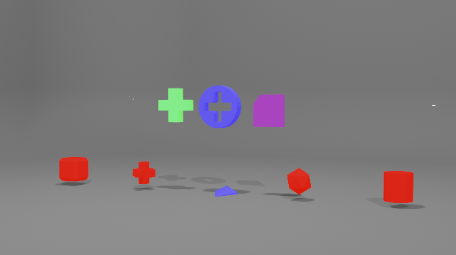 As mentioned previously in Figure 2, the game is supposed to look like an arcade game. To achieve this look, as seen on Figure 12, all 3D assets were created inside blender with a very low polygon count.

Figure 12. Rendered image of wat all the 3D assets look like within blender.

Besides the assets in Figure 12 all other aspects withing the game are made with 2D images. All bullets, skills and particles are made of very simple 2D shapes. With the planned style and concept arts in mind the game went through multiple graphics iterations, a few pictures showing the progress can be seen in Figure 13.

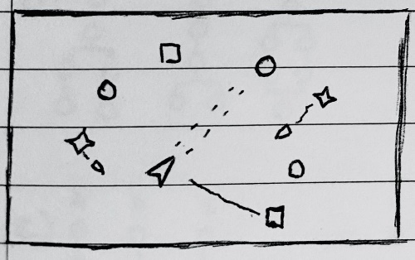

Figure 13. Contains the 2 original concept arts for the game and a picture showing both the unfinished and the finished state of the game.

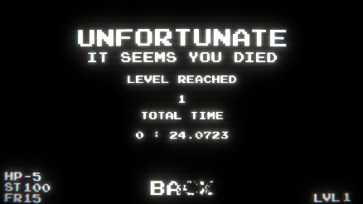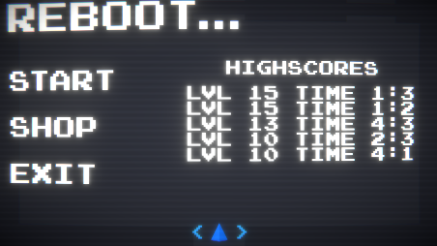When it comes to the UI there is not a lot of information that requires being displayed. As seen in Figure 13, during game play there are only 4 constant text fields displayed, the three fields on the left are dedicated to the player stats while the right corner is dedicated to the current level. As seen on Figure 14, The menu, pause and end screen all have a similarly simple design. They contain only the necessary information and buttons that allow the player to navigate through the game.

Figure 14. Captures of the game menu screen, pause screen and game over screen.

## 3.4 Sound Design:

When it comes to old consoles and arcade games, sound was created by using a single chip that was only capable of playing 3 tracks at once and most of time was made to play sound by the use of square waves controlled by simple electric currents. This leads to sounds being choppy and music being incredibly limited. To achieve a sound most sound effects within the game were created with only the use of square waves being manipulated. All sound effects and music within the game were created by a friend of the research team within the time span of one week, their portfolio has been linked within the digital references.

# 4.Method, Evaluation and Reflection:

## 4.1 Method:

After the game was completed, it was sent to players with a questionnaire to be filled after they do at least 5 runs, with this in mind the minimum play time for testers should be around 20 minutes. Testers were allowed to play more within their own time if they wanted, but no extra incentive was given to do so. The questionnaire contains questions such as “On a scale of 1 to 5, how difficult did you consider the game?”, “On a scale of 1 to 5, how frustrating did dying within the game feel?” and “On a scale of 1 to 5, how likely are you to play more of the game if an updated version is released to the public?”. After receiving the questionnaires back, each tester was put into one of three group depending on their performance: a player that is new to the genre, an experienced player, or a veteran player. With these groups in mind each question was analysed twice, once with a pool of all testers and one with the pool of testers separated into their respective groups.

## 4.2 Evaluation and Reflection:

After all questionnaires were collected, each participant was assigned to a group. In the end there were only 2 participants that fit the criteria for veteran player which was not enough to derive any sort of useful data from. Due to this they were added on to the pool of experienced players, leading to the new player group containing 4 individuals and the experienced players group containing 5. After separating the results of each group, the scores of each question were averaged and compared to see if the results match with the expected outcome.

Figure 15. Image of the graph containing the results separated by player skill level, experienced players are red and new players are blue.

As seen on Figure 15 most of the results were not in line with the expectations of the research team. The expected result would be the experienced participants having a higher score in enjoyment and retention while having a lower score in perceived difficulty of the game, frustration when dying in perceived overall improvement over the session. Interestingly despite what most would expect the results were the opposite in every scenario. Players that struggled to get the first boss felt that the game was 11% more fun and were 11% more likely to play the game again than players that were capable of reaching level 6 and above with ease. On top of that, the newer players also experienced less frustration from failing within the game and thought the game as slightly easier than the experienced players. The two participants that went against what is seen above were the two participants that were considered veterans. They were the only participants to complete all of the levels within the game, one of them doing so within 3 minutes and 31 seconds, and overall, they responded less negatively to dying and even considered the game easy, giving the difficulty a score of 2. Both of the veteran participants also reported playing a lot of matches besides the ones required for the study simply due to their own interest, one of them even bought all of the items within the store. Another interesting result that is more in line with what was expected is that every participant felt like whenever they improved the game became more fun regardless of if their perceived improvement score was low or high.

At first the results achieved seem to go against what was mentioned in all the studies provided, but in reality, it seems that the issue occurred due to the small pool of participants and a flaw on how the participants were grouped. Grouping participants by performance seems like the easiest way to separate the “mastery driven” players from the rest and get the answer to the question proposed in the introduction, “How do higher skill ceilings impact player satisfaction and retention?”. But this does not account for “mastery driven” players that had no experience with the genre before, as they only get a few tries for the study, these individuals don’t have the time to properly fail and improve. This in turn will make it seem like they are “helpless-oriented” players, which a lot of the time is not the case, they are simply not experienced yet.

To reframe the study the groups were separated again but this time in a way that would hopefully separate mastery-oriented players into their own group. This was done by checking which participants had a higher-than-average enjoyment and perceived difficulty score and a lower than average frustration score.

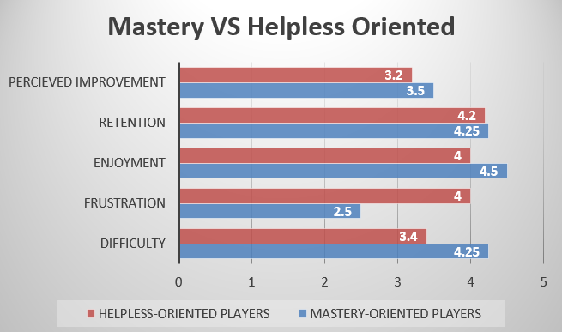

Figure 16. Graph containing the research data, but this time differentiated by mastery-oriented and helpless-oriented individuals.

As seen on figure 16, after rearranging the groups to better fit the description found on the studies regarding mastery-oriented individuals, the results become a lot more in line with the expectations set early on during research. The group of players designated as mastery-oriented found the game 25% harder than the rest of the players but were 60% less likely to get frustrated from dying. On top of that they reported having enjoyed the game more and feeling like they had improved more than the other players. This behaviour of not being frustrated by failures such as deaths is a core strength of mastery-oriented individuals (Craig Anderson 2020, p.6) ”Treating failure as a moment of reflection, being invigorated by failure, and considering these moments as setbacks rather than failures are hallmarks of mastery-oriented individuals”.

# 5.Conclusion and Future Work:

## 5.1 Conclusion:

When taking everything into account the answer to the question “How do higher skill ceilings impact player satisfaction and retention?” becomes more complicated than expected, but the answer indicated by the data is: A higher-skill ceiling game will improve satisfaction and retention of mastery-oriented individuals, but if the skill floor is also high there will be groups of players that will enjoy the game less. The best way to attract both the mastery and helpless oriented archetypes of player would be by having a higher skill ceiling overall, with in depth mechanics that the player could spend a lot of time mastering, while having a lower skill floor so that even players that aren’t looking for a challenge can have a way to enjoy the game. Overall, the game fulfilled its purpose, even if players ended up considering it much harder than the research team intended. However, with the time constraint taken into account a lot was accomplished and most of the future work planned is the addition of new features and improvements to some of the existing, as the game has a very solid and surprisingly enjoyable core.

## 5.2 Future Work:

When trying to figure out what to do next it is important to first understand what went wrong during research. Firstly, the biggest issue is the small participant pool present in the study. Without a proper pool of participants, the opinions of a single player can alter and muddy results, leading to inconclusive and untrustworthy data. In this case the data seems to paint a clear picture, but the only way to be sure would be by doing the study with a broader audience. Secondly, the participants gave the game a perceived difficulty score of 3.77 out of 5. This means that they considered the game to be quite a bit harder than the average game they’ve played. This becomes an issue because ideally the study would only cover higher skill ceilings, when in this case a higher skill floor was present too. During development this issue was foreseen to some extent and the research team tried mitigating it with the introduction of a simple tutorial on the first floor. This doesn’t seem to have helped much as it seems most players still struggled against the default enemies, even in the smaller quantities present in the early stages. Another issue with the testing was the time given to participants. When talking about high skill ceilings and mastery, a lot of time would be needed to gather reliable data on players that have made substantial progress in regards to achieving the skill level and in game mastery. Lastly the addition of more features would make the game more appealing to both groups. As the original grouping by performance was flawed either way, keeping the skill tree in might’ve given helpless-oriented players something else they could work with and lower the skill-floor enough to improve their retention too. Adding the skill tree back in will be one of the next priorities. A couple participants also ran into two specific bugs, one where the upgrade couldn’t be picked up and once in which sometimes enemies would leave the arena and never return, making completing a level impossible. Both of these issues should be easily fixable and were rare enough to neve show up during development testing.

# References

## Academic References

[1] C.G. Anderson, K. Campbell, C. Steinkuehler (2019). “Building persistence through failure: the role of challenge in video games” Proceedings of the 14th International Conference on the Foundations of Digital Games.

<https://dl.acm.org/doi/abs/10.1145/3337722.3337741>

[2] Klimmt, C., Blake, C., Hefner, D., Vorderer, P., & Roth, C. (2009). Player performance, satisfaction, and video game enjoyment. In S. Natkin & J. Dupire (Eds.), Entertainment Computing – ICEC.  
<https://link.springer.com/chapter/10.1007/978-3-642-04052-8_1>

[3] Hefkaluk N, Linehan C and Trace A. (2024). “Fail, fail again, fail better.” International Journal of Human-Computer Studies. 183:C. <https://www.sciencedirect.com/science/article/pii/S1071581923002082?via%3Dihub>

[4] Cuerdo M, Mahajan A, Mao J and Melcer E. (2023). “Try Again?: A Macro-Level Taxonomy of the Challenge and Failure Process in Games” 2023 IEEE Conference on Games (CoG).  
<https://ieeexplore.ieee.org/document/10333199>

[5] C. G. Anderson (2020) "Hits quits and retries-player response to failure in a challenging video game", International Conference on the Foundations of Digital Games.  
<https://dl.acm.org/doi/abs/10.1145/3402942.3403025>

## Bibliography

J. Juul, The art of failure: An essay on the pain of playing video games, MIT press, 2013.

## Ludography and Digital References

Portfolio of the friend responsible for sound effects:

<https://www.bernardohita.com>

Font Used within the UI and Menus:

<https://www.dafont.com/joystix.font>

NekoJin116 (2023) “Unity CRT TV VFX tutorial - URP/BuiltIn with no shaders!”

<https://www.youtube.com/watch?v=49KVkXXpFB4&ab_channel=Nekojin116>

Brackeys (2018) “START MENU in Unity”

<https://www.youtube.com/watch?v=zc8ac_qUXQY&t=327s&ab_channel=Brackeys>  
Small Hedge Games (2024) “PLEASE use a Unity SOUND MANAGER! - Full Tutorial  
<https://www.youtube.com/watch?v=g5WT91Sn3hg&t=337s&ab_channel=SmallHedgeGames>  
MuddyWolf (2023) “Add Killer Enemies to Your Game - 2D Top Down Shooter - Unity Tutorial"  
https://www.youtube.com/watch?v=N1BKXCxM_hA&ab_channel=MuddyWolf